
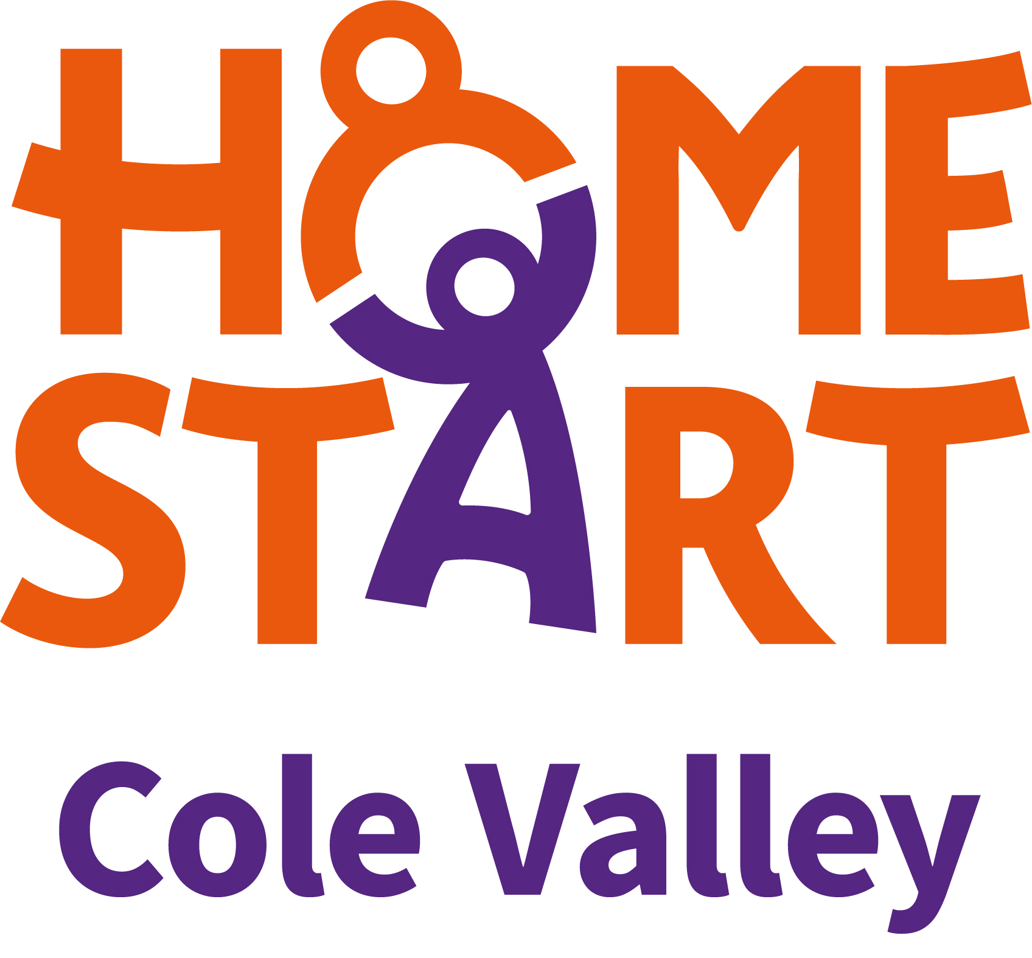

Ante-natal Results and Choices (ARC)

Outreach Coordinators

2 year fixed term contract

Part-time 18 hours per week.

NJC Scale 14 - £29,540 per annum pro rata.

We are recruiting for this new and exciting project.
We are looking for 2 x Part-Time Coordinators, who will lead this new project aimed at improving pregnancy aspirations and readiness in communities, particularly those less likely to engage with maternity services. The project will focus on healthy conversations, accessible and accurate information, and equitable access to interventions, helping reduce inequalities and support informed pregnancy choices. Excellent interpersonal skills; ability to develop a new service, confidence in working within a diverse community; and ability to provide compassionate support are essential.
The posts will involve hybrid working across the city with the posts based in the Central Birmingham or Tyseley areas.

Home-Start Birmingham is a leading family support charity, working in local communities across the city. We support parents to build better lives for their children, to give them the best possible start in life.
Antenatal Results and Choices (ARC) are a UK-wide charity offering impartial information and specialist support to parents undergoing antenatal testing. ARC also partners with healthcare professionals to promote high-quality, equitable ante-natal care.
We want to hear from you if you have:
*Education to A Level standard or equivalent qualification(s).
*Experience of working with parents in pregnancy
*A supportive, non-judgemental and compassionate approach
*The ability to plan and manage the development of a new service.
*A valid driving licence and use of a car.

We are committed to equality of opportunity and to safeguarding and promoting the welfare of children and adults. We expect all employees to share this commitment. We ensure that our recruitment and selection practices reflect this.

The role is subject to a Enhanced criminal records check
through the Disclosure and Barring service.

Full Induction will be provided to the successful candidate.

Closing date: Friday 27th March 2026

For more information or an application pack please contact admin@homestartbcsw.org

Home-Start Birmingham Central and South- West  CIBA Building, suite 1, LGF  146 Hagley Road, Birmingham, B16 NX.  Tel: 07845 085488  Registered Charity 1114963 | Home-Start Cole Valley  272 Kings Road (McGowans)  Tyseley, Birmingham B11 2AB  Tel: 07854793737  Registered Charity 1107901

